**Assignment -3**

**Geotechnical & IOT Monitoring methods**

**Anjali Dileep**

**Am.en. p2geo22004**

**Extended abstract and Block diagram**

**Project Title** - An IoT-based real-time saline water Intrusion and Groundwater level monitoring system and salinity Mapping.

**Introduction**

Saltwater intrusion to the aquifers is one of the most widespread problems of the world and

that endangers future water extraction from coastal aquifers. Coupled with a continuing

sea level rises due to global warming, the coastal aquifers are under severe threat.

Saltwater intrusion is the process by which saltwater from oceans or seas infiltrates into underground freshwater aquifers, resulting in a reduction of the freshwater available. The problem becomes exacerbated particularly in the dry season when rainfall is inadequate and incapable of lowering the concentration of salinity on surface water and leaching out salt from soil.

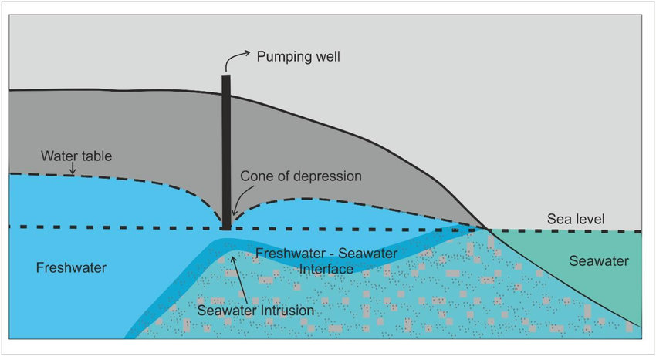

Fig 1: - Salt water intrusion Diagram

The relationship between saltwater intrusion and groundwater level is complex. The lower the groundwater level, the greater the risk of saltwater intrusion. When the groundwater level is high, there is a greater buffer between the freshwater and saltwater, and the risk of saltwater intrusion is lower. when the groundwater level is low, the pressure gradient between the freshwater and saltwater is higher, and the risk of saltwater intrusion is greater.

In addition, the rate of pumping can also affect the relationship between saltwater intrusion and groundwater level. When pumping rates are high, the groundwater level can drop rapidly, increasing the risk of saltwater intrusion.

The relationship between saltwater intrusion and groundwater level is affected by factors such as characteristics of the aquifer and the pumping regime. Monitoring Groundwater levels and salinity using IoT -based systems can determine the relationship and develop strategies to prevent saltwater intrusion.

The IoT method is relevant in detecting salinity because the Traditional monitoring methods have some demerits like

* involve manual measurement of water levels and water quality parameters at wells or boreholes
* time-consuming and expensive

Using IoT to detecting saltwater intrusion and groundwater monitoring has numerous benefits including

* Real -time monitoring - This allows real-time information on salinity levels in water bodies and allows for rapid response to changing conditions and can help prevent damage to crops, fisheries, and other aquatic ecosystems.
* Cost-effective
* Gives accurate data
* Early warning
* Improved decision-making

**Objective**

The main aim of this project is to develop a real time IoT based saline water intrusion and groundwater level monitoring and the objective of this project is

* To create an open-source system with low cost
* To constantly monitoring the salinity level and water level in a body of water and feedback the information to a remote monitoring centre in real-time.
* Finding the long- term trend and pattern of the groundwater level of the aquifer system over periods.
* Integrating the GIS system to visualizing the extent of saltwater intrusion using the sensor data.
* While detecting the saltwater intrusion we can ensure the sustainability of freshwater resources and ecosystems.

**Methodology**

In this methodology we are using IoT sensors to detect saltwater intrusion in areas where it is not desired. The sensors are configured to detect changes in salinity levels and groundwater level, and send alerts when levels exceed a certain threshold. The data collected by the sensors is analyzed to identify patterns and trends, and appropriate action is taken to prevent or mitigate saltwater intrusion.

Using ArcGIS pro/ArcMap to create the extend of saltwater intrusion levels.

The methodology can be divided into 5 stages

* Sensing Deployment: IoT-enabled sensors are installed in selected locations where groundwater is at risk of saltwater intrusion. The sensors measure different data points such as groundwater level, conductivity, temperature, and pH.
* Data collection: The sensors collect data in real-time, which is transmitted to a central database or cloud-based platform using wireless connectivity.
* Data analysis: The data is analysed in real-time to provide insights into detecting patterns and identify anomalies that could indicate saltwater intrusion and groundwater level changes. Thresholds and alert triggers are set based on an analysis of sensor data, such as record groundwater level and pH changes. Using Gis Platform for identifying the extend of salinity in the study area.
* Alerts and notifications: The system generates alerts and notifications in real-time when salinity levels reach critical levels or groundwater level depleted drastically over period changes.
* Soil Mapping: After getting the data using ArcGIS /ArcMap software we can map the salinity extend in the study area.

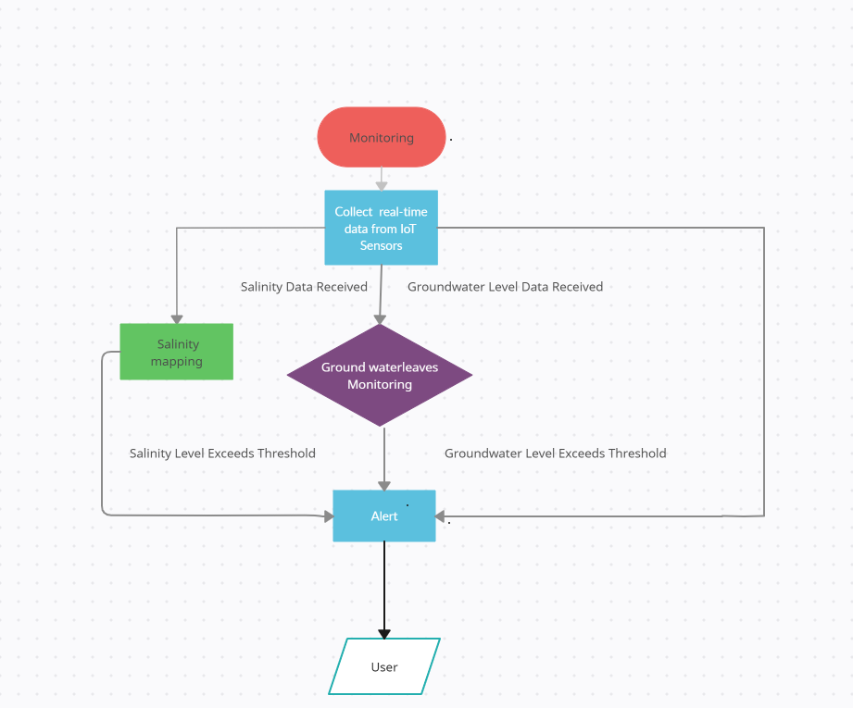

Fig 2: - Methodology Diagram

**Raspberry Pi Microcontroller**

Raspberry Pi is a single-board computer that runs on Linux operating system and is best suited for complex applications that require high processing power, networking capabilities, and graphical user interfaces. Raspberry Pi provides multiple USB ports, Ethernet, Wi-Fi, and Bluetooth connectivity and can run complex algorithms and software applications.

**LoRa WAN Technology**

LoRa (Low Power, Long Range) is a wireless communication technology specifically designed for long-range, low-power applications in the field of Internet of Things (IoT). LoRa WAN is a MAC (Media access control) protocol for WAN. It can provide real-time data about the quality and quantity of groundwater and saltwater intrusion through the use of sensors and Internet of Things (IoT) devices. It is developed and maintained by the LoRa Alliance, an industry association of companies collaborating to drive the adoption and standardization of LoRaWAN (LoRa Wide Area Network). LoRa uses a modulation technique called Chirp Spread Spectrum (CSS). LoRa technology does not need a large transmission power but can still transmit long distances because its signals can be received at long distances even with a lower signal strength than ambient noise.

In LoRa the data collected by the sensors can be transmitted to a LoRa gateway, which connects to the internet and sends the data to a cloud-based monitoring system. This data can be used to identify and manage saltwater intrusion, as well as to detect water levels, temperature.

**TDS Meter Sensor**

TDS, or Total Dissolved Solids, refers to the concentration of dissolved substances in water, including salts, minerals, and other organic and inorganic compounds. Salinity, on the other hand, refers specifically to the concentration of salt in water.  
A TDS sensor can be used in salinity detection by measuring the electrical conductivity of the water, which is directly proportional to the concentration of dissolved substances. Salts, being ionic in nature, dissolve in water to form charged ions. It can work with a wide range of dc supply (3.3~5.5 V) with the analog signal output from 0 to 2.3 V which corresponding to TDS values ranging from 0 to 1000ppm with an accuracy of 10% FS (at 25 ℃). Because salt is a part of TDSs and therefore will be either a part or all of the reading values. In this work, we use the TDS meter sensor to estimate the amount of salt in water.

**DS18B20 Thermometer**

The DS18B20 is a digital thermometer sensor known for its accuracy and flexibility.

It operates on a one-wire digital communication protocol that allows multiple sensors to be connected to a single input/output (I/O) port of a microcontroller. The sensor measures temperature in the range of -55°C to +125°C with an accuracy of ±0.5°C, making it suitable for various environmental temperature sensing applications. The sensor communicates over a 1-Wire interface, allowing multiple sensors to be connected on a single data line. It supports programmable resolution, ranging from 9 to 12 bits, and can be powered from 3.0V to 5.5V. It has a unique 64-bit serial code that allows for easy identification and communication with multiple sensors. Its small size, low cost, and ease of use make it a popular choice for temperature sensing applications in the fields of automotive, medical, and industrial automation.

**Ultrasonic Sensor HY-SRF05**

The HY-SRF05 ultrasonic sensor can be used to measure groundwater level by finding the distance between the transceiver and the surface of the water with a precision of ~30 mm. It sends out a short ultrasonic pulse (40 kHz) that reflects on objects in front of the sensor. This signal is then read back by the sensor and the duration of the received signal is reflected

in the ECHO pin.

**LoRa Module**

A LoRa module is a type of hardware module that utilizes LORA (Long Range) technology to allow for long-range wireless communication. LORA modules are commonly used in IoT (Internet of Things) applications, where low power consumption, long-range connectivity, and reliability are important factors. These modules can transmit data over long distances while using minimal power, making them ideal for applications such as smart agriculture, smart cities, and remote monitoring. In this study we are using RN2483 LoRa Transceiver module. This module complies with the LoRaWAN Class A protocol specifications. It integrates Radio Frequency, a baseband controller, command Application Programming Interface (API) processor, making it the best long-range solution currently.

**LoRa Gateway**

A LoRa gateway is a device that allows the communication between LoRa Modules. LoRa Gateway works as a server for several LoRa nodes for sharing data. Each gateway has a temporary storage device for holding the data before uploading it to the cloud data certain pre specified time.

The data received by the LoRa Gateway will be uploaded to the cloud with a timestamp, module ID and other information to identify the source of data collection.

**System Architecture**

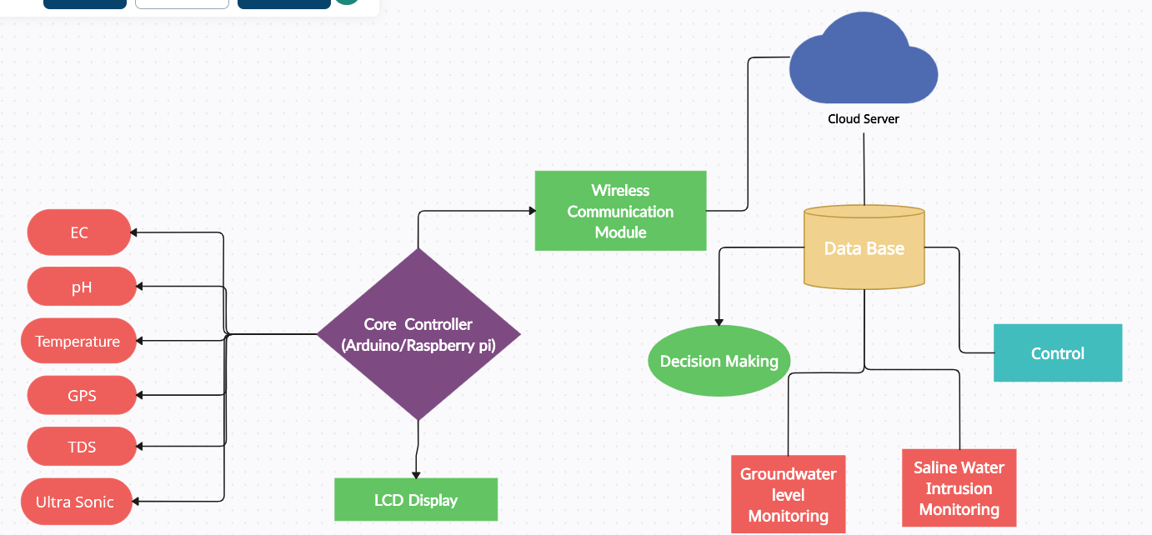

Fig 3: - System Architecture Flow diagram

**Expected Outcome**

The study area is Alappad village in Kollam, this is a coast village which is near the Arabian sea. The region is already affected by salinity water issues because the region is varied close to sea level. but the 2004 Indian Ocean earthquake and tsunami has drastically affected the region and as well as the groundwater system of the region also. The black sand mining of the coastal by IREL affect the groundwater system. It’s been over a decade after the tsunami happen and the people in the village is not using any groundwater. So, there is a possibility the salinity will be reduced.

Using IoT in this project to find the salinity intrusion level and groundwater level we can easily and cost efficiently find the intensity of the salinity in that area. And by using GIS technique we can Map the extend of the salinity level of that area.

**Expected Outcomes**

* Identifying groundwater level flucation and trend and patterns over period.
* Identifying salinity level and its trend and patterns over period.
* Using GIS salinity mapping can be done and finding the areas where salinity is high and low and we can suggest the salinity prevention methods according to that.
* After identifying the salinity intensity, we can suggest for a filtration method that the villagers can use the water for irrigation and other purpose.

**Conclusion**

Now a days we are living in AI world, where technology doesn’t have any limits. The rapid expansion in technology also lead to expansion in Internet of Things (IoT) devices and applications .In this study , a low-cost ,low-power ,wireless sensor network for saline water intrusion monitoring was developed to provide a real-time groundwater level data to support the decision making in determine the saline intrusion .Saline water intrusion is the process by which when withdrawal of fresh groundwater from coastal aquifers results in declining groundwater levels migration of saline water causing deterioration of groundwater quality.

The significance of this project is that using iot method than the traditional method is

* Traditional method is more costly and require time consuming and has large chance of contamination.
* Using IoT it gives us real -Time data, cost effective, gives accurate data, can make early warning system.

The expected outcome of this project is to identify the salinity in the study are and monitor the water level. Identifying the Salinity potential zone and make them aware and prevention methods can be used. Intensity of the salinity can determine how much saline present that use filtration methods to get the water to useable quality.

**Block Diagram**

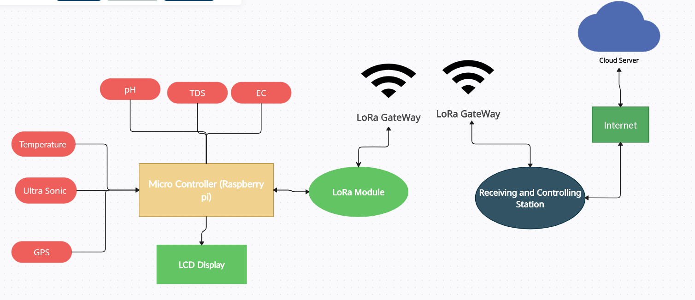

Fig 4: - Block Diagram

The proposed system consists of an onsite module and a remote module. The onsite module will communicate with the LoRa gateway through LoRa WAN Network, it has a network capacity of several hundred connections at a time. The gateway is connected to the internet through an ethernet connection or Wi-Fi. The onsite modules communicate with the LoRa Gateway.